JOUR 4251
7.1 Attitude toward advertising and the brand (cont.)
Make sure to get an In-Class Assignment form before class starts and
write down your name on the form.
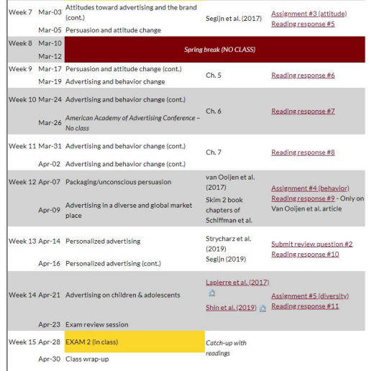
Midterm evaluations
“She cared about our feedback”
“She genuinely cared about our opinions”
Start Stop Continue
Media multitasking / Multiscreening
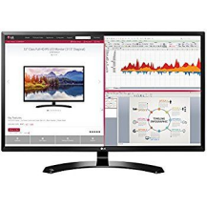
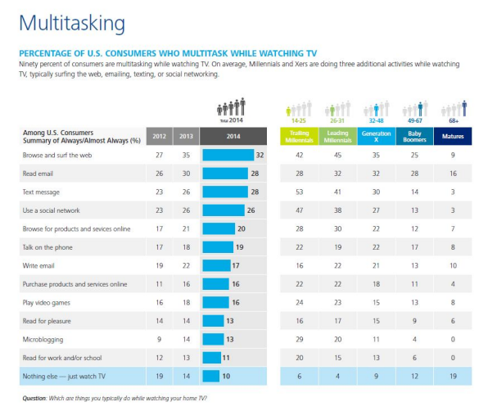
ICA 3a. Can you really multitask?
A B C D E F G H I J K L M N O P 1 2 3 4 5 6 7 8 9 10 11 12 13 14 15 16
Consequences for advertisers?
Consequences for advertisers?
● Consistent finding in the literature that multitasking has a negative effect on memory
● Mixed results on brand attitude
○ Positive effects on attitude: resistance
○ Negative effects on attitude: recognition
○ No results
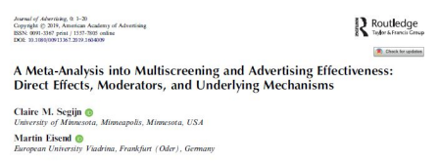
Why is it difficult to multitask?
^{Capacity interference} Structural interference
ICA 3b. Does it matter what you do?
ICA 3b. Does it matter what you do? Turn around your ICA and answer the questions.
Can we help multitaskers?

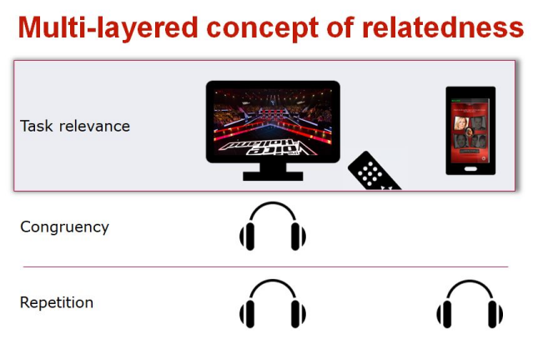

Experiment 1 
Ekorst - dinigret - zemuik
Rapeip - Feetolon - ijregt
Experiment 2
What did we expect?
_{multiscreening Attention TV} Program
Related
Involvement
What drives
attention?
Brand memory Brand attitude
Think like an advertiser (or broadcaster) What can you do with this information?
What’s next
Due by Thursday, March 5 (2:30 pm)
● Submit reading response #5 on Segijn et al. 2017
○ NOT Chapter 5 (that is reading response #6)
● Submit assignment #3
○ Check format guidelines (easy points!) + grading rubric
● Start reading Chapter 5 of the book
○ We will start talking about persuasion and attitude change on Thursday

